# Read the information sheet before providing photos to Firearms Policy and Recording Unit (FPRU).

### Purpose

This information sheet provides instructions on the process for the minimum standards of photographing firearms for the purposes of identifying the National Firearms Identification Database (NFID) template.

### General information

* Ensure .JPG format is used when sending the images through to [firearmsregistry@pfes.nt.gov.au](mailto:firearmsregistry@pfes.nt.gov.au)
* Send the images through as attachments – do not embed the images in the text
* Ensure firearm is placed on a neutral background with good lighting
* Provide minimum of 6 photographs as outlined below
* Include all firearm manufacturers marks or stamps

### Overall photo

* Take a photo of both sides of the firearm
* Photo should be taken as close as possible
* There should be minimal gap between the edge of the firearm and the border

Examples

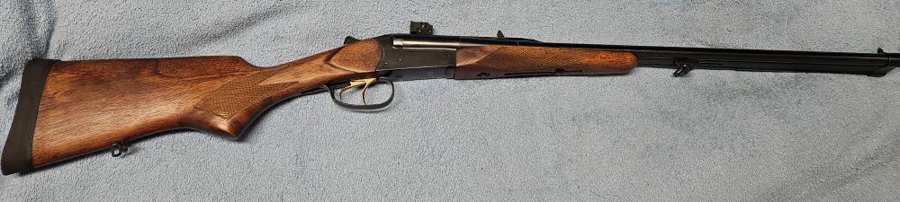

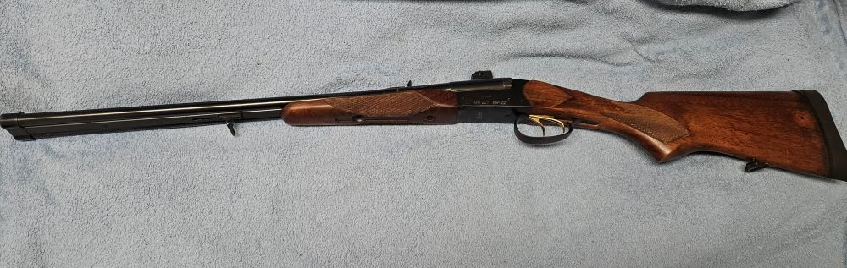

### 3-quarter photo

* Take photo from the side with action – or if ambidextrous, take photo from the right side.

Examples

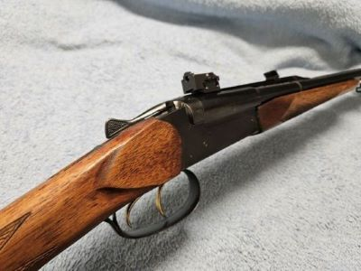

### Serial number and other markings

* Zoom in to ensure that shadows do not interfere with the lighting
* Capture the image as close as possible while maintaining clear detail
* Crop the image around the marking while leaving enough surrounding details to indicate where the markings are located
* Include all firearm manufacturers marks or stamps

Examples

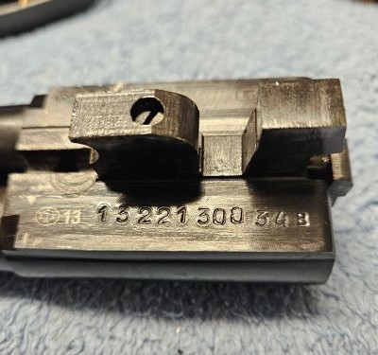

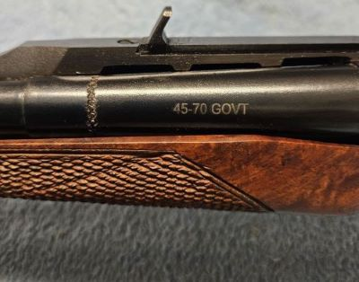

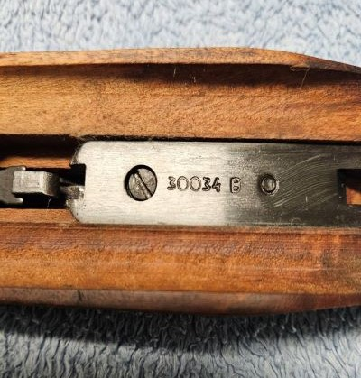

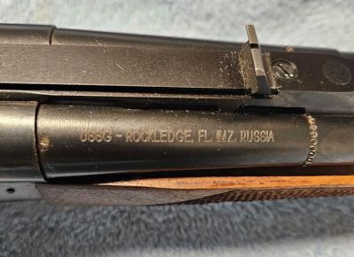

### 

### Need assistance with your application?

For clarification or enquiries, please contact the Firearms Policy and Recording Unit (FPRU) on   
(08) 8922 3543 between 8 am and 11am Monday to Friday excluding public holidays or email [firearmsregistry@pfes.nt.gov.au](mailto:firearmsregistry@pfes.nt.gov.au)