  - Round Two 2024-25
Project Application Form
Please complete all sections in this form and return to the NT Emergency Service by
5pm Wednesday 20 March 2024 via email to: ntdrf@pfes.nt.gov.au.

The following must be completed for the project to be considered:

☐ 1. Project Application - this document | ☐ 2. Project Logic - this document
☐ 3. Project Budget - NEMA template xlsx | ☐ 4. Risk Assessment - this document
☐ 5. Supporting evidence - provided by you | ☐ 6. Business case (for waiver requests only)

This Application Sections:
- Applicant Information | - Project Information
- Project Location | - Project Alignment with DRF
- Project Funding Summary | - Responses to the DRF Selection Criteria
- Attachments and Supporting Evidence | - Declaration, authorisation and acknowledgement

Project Title
(maximum 15 words)

- APPLICANT INFORMATION
Entity Name
ABN
Contact Person
(Title; First and Last Name)
Contact Position
Email
Phone
Primary Address
(Enter a street address.)
Postal Address

Applicant Type
☐ Registered charity or not-for-profit organisation | ☐ Social enterprise
☐ Non-government organisation | ☐ Local government body
☐ State/Territory government body | ☐ Service provider
☐ Community organisation | ☐ Commercial enterprise or business
☐ Individual | ☐ Research and/or academic body
☐ First Nations body | ☐ Diversity organisation
☐ Disability provider | ☐ Other (please specify)

Delivery Partners
(List any third-parties who will be working with the Applicant to deliver the project. Insert additional rows if needed. Leave blank if the Applicant will be solely responsible for project delivery).
Partner name | Partner type
[Insert Partner 1 name] | [Select and enter one descriptor from the list of Applicant types above that best describes Partner 1 – e.g. Local government body]
[Insert Partner 2 name] | [Select and enter one descriptor from the list of Applicant types above that best describes Partner 2 – e.g. Individual]
Etc | Etc
Publication - If this application is successful, do you consent to have the names of Delivery Partners published by NEMA?
NEMA will publish the identity of the Applicant, the project title, the project description and the amount of funding awarded. NEMA will also publish the names of any Delivery Partners, unless requested not to.
☐ Yes | ☐ No

Checklist
Project readiness | - Has the project secured relevant internal approvals?  If the application is provided with ‘in principle funding’, the funding resources must be finalised (approved) before the NT can sign an agreement with NEMA for the project.
 | - Will the project be ready to commence from January 2025?
 | - Does the Project have assigned resources with the relevant experience and project management capability to deliver the project?
Project funding | - Is the Project a large scale project of greater than $1 million, including co-contributions?
 | - Has the Project secured, or have a viable plan to secure co-contribution funding?
- Is the Project requesting a funding waiver?
- If yes, has a supporting business case been completed for the waiver request?

- PROJECT INFORMATION
Brief project description

Provide a succinct summary of the project activities and expected outcomes. This should be written clearly and without jargon as it will be published to the general public if the project application is successful
Maximum 70 words
What is the Problem/ Issue?

Describe the underlying problem that the project is seeking to address
Maximum 100 words
What are the Solutions and Goals?

Explain how the project intends to address the problem/issue outlined above
Maximum 100 words
What are the proposed Project Outcomes?  Maximum 100 words | - i.e. The project will raise awareness of…..  - XXXX  - XXXX
Will this project directly support people from  (or who identify as) belonging to, specific population sub-groups? | - Aboriginal and Torres Strait Islander Peoples  - Children (aged 0 -15 years)  - Individuals experiencing domestic and family violence  - People from a culturally and linguistically diverse background  - People from the LGBTQI+ community  - People with a disability  - People with mental illness  - Seniors  - Youth (15-24)  - Other – please specify
Project duration  please select one only | - Up to 1 year  - Up to 2 years  - Up to 3 years
Project place-based focus:  If the project is place-based, has it been developed in consultation with local government(s) and/or affected communities, including First Nations stakeholders?  Maximum 300 words | - Not applicable (i.e. not a place-based project)  - Yes  - No  Place based focus – Projects which focus on practical, ‘on the ground’ impacts in one or more local government areas that align with Program Objectives.  If selecting ‘yes’ or ‘no’, briefly describe any consultation that has occurred or reasons for not consulting, including who has been consulted, their level of support for the proposal, any significant issues or objections that have arisen during stakeholder consultations, and how the Applicant intends to address any residual issues/objections if awarded DRF funding.
Target population:  Estimated size of the target population group(s), including any sub-groups, that are expected to directly benefit from the project  (select one option only) | 0-100 people  101-1,000 people  1,001-10,000 people  10,001-100,000 people  100,001-500,000 people  500,001-1,000,000 people  1,000,001-5,000,000 people  >5,000,000 people
Target group(s):  Target group(s) that the project is intending to impact?  (select any that apply) | Australian Government  Community group/non-profit  Emergency responders  Families  Farmers  Home owners  Individuals  Local Governments  Early childhood education and care services  Schools (Primary & High Schools)  Service Providers  Small Businesses  State and Territory Governments  Students  Universities and research institutions  Other (if selected, please specify): _____________________________
Demographics:  Does, or will, this project directly support people from, or who identify as belonging to, specific population  sub-groups?  (select any that apply or ‘no/none of the above’ if none apply) | First Nations  Children (<15 years)  Seniors (65+ years)  Youth (15-24 years)  Women  Culturally and Linguistically Diverse  People from the LGBTQIA+ community  Individuals experiencing domestic and family violence  Individuals experiencing homelessness, unemployment or poverty  People with a disability  People living with a mental health condition  People living in regional, rural or remote locations  No / none of the above
Insurance risk:  Does the project have a focus on or expected benefits for insurance affordability and/or availability, through risk mitigation or other means? | If answering ‘yes’, provide a brief explanation, including the nature, quantum and basis of any expected benefits. Otherwise, please select ‘not applicable’.  (maximum 200 words)  Note: responses to this question will be used for analytical and reporting purposes only by NEMA
Project impact:  Does the project have the potential to adversely impact a matter of national environmental significance under the Environment Protection and Biodiversity Conservation Act 1999 (Cwlth)? | No  Yes  Note: NEMA will not support proposals which include activities with the potential to adversely impact a matter of national environmental significance.

- PROJECT LOCATION
Geographic extent  (select one option that best describes the spatial area of the project) | Town/City  Local Government Area (LGA)  Multi-LGA  State/territory wide  Multi-jurisdictional  National
Project Location Type  (select only one option) | - LGA select below  - Multi-LGA select below  - State/Territory Wide  - Multi-State/Territory
Local Government Areas  Select all LGAs relevant to the project | Darwin  Belyuen  Litchfield  West Daly  Victoria Daly  West Arnhem |  | Wagait  Palmerston  Coomalie  Katherine  Central Desert  Unincorporated Area | Tennant Creek  East Arnhem  Barkly  Alice Springs  MacDonnell  Roper Gulf
Site Address(es)  (Provide the street address where your project will be undertaken (e.g. site where infrastructure will be built or service will be delivered). If you have multiple sites, add additional rows and enter the address of each site.  If the project will span a broad area rather than specific locations (e.g. a service provided to an entire city, LGA, or the territory) or specific site addresses are yet to be determined at the time of application, provide at least one address within each jurisdiction selected above from where project delivery will be coordinated.  A site address must be a street address; do not provide a postal address, institution or building name). | Site | Street address, suburb/town, state/territory & postcode
 | Site 1:
 | Site 2:
 | Site 3:
 | Site 4:

- PROJECT ALIGNMENT with the Disaster Ready Fund
DRF objective(s)  (Select all objectives that the project will contribute to) | Knowledge - increase the understanding of natural hazard disaster impacts.  Resilience and Preparedness - increase the resilience, adaptive capacity and/or preparedness of governments, community service organisations and affected communities.  Mitigation and Prevention - reduce the exposure to risk, harm and/or severity of a natural hazard’s impacts.
Hazard type(s) being targeted  (Select all that apply) | Earthquakes  Landslides (including avalanches, mudslides, sinkholes)  Tsunamis  Bushfires (including wildfires)  Coastal hazards (including coastal erosion, and coastal inundation; sea level change  Cyclones  Floods (including flash flooding)  Heatwaves  Pollen storms  Storms (including severe thunderstorms, hailstorms and blizzards; east coast lows; geomagnetic solar storms (X or M Class))  Tornados (including damaging wind incidents and dust storms)  Other (if selected, please specify): __________________________________
Primary project activity type  Select one activity type that best aligns with your project proposal.  Refer to Section 3.3.3 of the Guidelines for further information.  Your chosen primary activity type must correspond with your Primary DRF Stream – e.g. If you selected Stream One as your primary stream, select a primary activity type from the list of Stream One eligible activities only | Stream One eligible activities:  Supporting a better understanding of risk, through a better evidence base to understand and raise awareness of risk  Projects that deliver risk reduction plans at the community, regional and state levels to mitigate identified risks and impacts  Strengthening representational and inclusive decision making by enhancing governance networks and communities of practice  Adaptation projects that improve land use planning and development practice projects  Projects, including social projects, that build the capacity and capability of businesses, community sector organisation and/or at-risk communities  Projects that enable and incentivise private investment in disaster risk reduction
Stream Two eligible activities:
Investment in grey infrastructure
Investment in green-blue infrastructure (including nature based solutions)
Investment in social infrastructure (including nature based solutions)
Investment in hazard monitoring infrastructure
Business case or feasibility study development for future infrastructure
Domain(s)  (Select all domains that the project relates to. Descriptions of each domain can be found in the Application How-To Guide) | Social  Built  Natural  Economic

Where your project goes across BOTH DRF streams, identify the secondary stream
Secondary DRF stream and secondary project activity types  NEMA recognises that projects may overlap streams and activity types. If your project aligns with more than one stream and/or activity type, select the secondary stream (if applicable) and any relevant secondary activity types from the lists provided.  Only select streams and activity types that have not already been selected in the preceding questions (i.e. there is no need to repeat your primary stream and activity type here).  These fields can be left blank if your project only relates to the primary stream and primary activity type selected above | Secondary DRF Stream:  Stream One - Systemic Risk Reduction  Stream Two – Infrastructure  Secondary Project Activity Types:  - Stream One eligible activities  Supporting a better understanding of risk, through a better evidence base to understand and raise awareness of risk  Projects that deliver risk reduction plans at the community, regional and state levels to mitigate identified risks and impacts  Strengthening representational and inclusive decision making by enhancing governance networks and communities of practice  Adaptation projects that improve land use planning and development practice projects  Projects, including social projects, that build the capacity and capability of businesses, community sector organisation and/or at-risk communities  Projects that enable and incentivise private investment in disaster risk reduction  - Stream Two eligible activities  Investment in grey infrastructure  Investment in green-blue infrastructure (including nature based solutions)  Investment in social infrastructure (including nature based solutions)  Investment in hazard monitoring infrastructure  Business case or feasibility study development for future infrastructure

Project’s Alignment with the Second National Action Plan
Identify any Second National Action Plan National Actions to implement the National Disaster Risk Reduction Framework Priorities that the project aligns with?  (Select all that apply. Leave blank if none apply) | Create consistent, accessible information, tools, guidance and programs to help everyone better understand their disaster risk and responsibilities, prepare risk mitigation plans and take appropriate action to manage their risks.  Improve disclosure of disaster risk across all stakeholders to support a shared understanding of risk and the development of hazard risk mitigation plans  Collaborate to harmonise and improve how data, information and research is produced, shared, tailored and used to inform effective approaches to risk reduction.  Build evidence, intelligence and insights by integrating local knowledge and lived experience, including traditional knowledge, to inform effective decisions.  Facilitate continuous improvement through monitoring and evaluating risk reduction activities and sharing lessons  Create hazard mitigation plans and scale across different levels, from individual and household plans, through to community, regional, state and national plans.  Strengthen risk-informed decision-making across all systems to address disaster risk and deliver co-benefits.  Strengthen risk-informed land-use planning, building control systems and settlement decisions to minimise the creation of new risk and address legacy risk.  Incorporate a range of community values into decision-making processes that acknowledge the broader benefits achievable through inclusive disaster risk reduction.  Enable and equip decision-makers to make adaptive and agile decisions when faced with imperfect information, and in a changing risk environment.  Strengthen the capability and capacity of individuals and communities to become leaders and make informed risk reduction decisions relevant to their local contexts.  Facilitate greater emergency management sector professionalisation, capability and participation, including volunteerism.  Align investment decisions with hazard risk mitigation plans and strategies at local, state, regional and national levels.  Explicitly consider future disaster risk and betterment in investment decisions for disaster-specific and other funding streams.  Create mechanisms for innovation, valuing resilience beyond avoided costs and showcase project results which demonstrate effective outcomes.
Provide the environment for sustainable funding and consistent policy settings and processes to encourage the development of pipelines of investment for disaster risk reduction projects.
Pursue innovative finance models for risk reduction initiatives, including through co-investment and public-private partnerships, to encourage greater funds towards resilience outcomes.
Enable greater integration of disaster risk reduction into the financial system by exploring cooperation, optimising policy, regulatory frameworks, standards and guidance.
Create spaces, opportunities and governance arrangements for inclusive and diverse community representation, participation and access to the disaster management system.
Form and encourage meaningful partnerships and support place-based, community-led, locally-implemented, regionally coordinated approaches to disaster risk reduction, which ensure equity and inclusion across the system.
Better align recovery and resilience activities, governance, funding, policy and processes to support betterment and long-term disaster risk reduction.
Understand barriers and disincentives to risk reduction to ensure all in Australian society are empowered to exercise choice to reduce risk without disadvantage.
Strengthen mechanisms to improve cooperation and further support devolved disaster risk reduction planning and management at local and risk-appropriate regional levels.
Better align disaster risk and related disciplines which result in similar local impacts, particularly physical climate risk mitigation and adaptation and drought, to simplify and streamline governance, plans and effort.

- PROJECT FUNDING SUMMARY (GST Exclusive)
 | Total Commonwealth funding sought | Total co-contribution being offered | Total project value  (Total Cwlth +  total co-contribution)
Amount ($) | $(e.g. $250,000) | $(e.g. $250,000) | $(e.g. $500,000)
Proportion of total project value (%) | % (e.g. 50%) | % (e.g. 50%) | 100%

Applicant Co-contribution details (GST exclusive)
Source | Co-contribution Breakdown |  |  | Co-contribution status at time of application submission  (select one) | Territory government entity?  (Y/N)
 | Financial component  ($) | In-kind component  ($) | Total  (Financial + In-kind)  ($)
Applicant | $ | $ | $ | Confirmed  In-principle | Yes – specify agency  No

Delivery Partner: A third-party organisation, individual or entity that will collaborate with a DRF Project Applicant to deliver, or deliver aspects of, successful DRF projects.
Delivery Partner Co-contribution details (GST exclusive)
Source | Co-contribution Breakdown |  |  | Co-contribution status at time of application submission  (select one) | Territory government entity?  (Y/N)
 | Financial component  ($) | In-kind component  ($) | Total  (Financial + In-kind)  ($)
Delivery Partner 1 | $ | $ | $ | Confirmed  In-principle | Yes – specify agency  No
Add as required
TOTAL | $ | $ | $

Other Funding Sources
Has financial assistance previously been or currently being sought or provided through Commonwealth, State/Territory or other initiatives to support this project? | No  Yes – If yes, provide further details below for each funder (add more rows if needed).
 | Funding Source | Amount ($) | Date applied for/awarded | Status/ Outcome | Brief Description of support sought/provided, including the purpose of the funding and the Australian Government Reference Number (AGRN) where relevant

Co-contribution Waiver Request
Is a co-contribution waiver or reduction being sought for his project? | No  Yes - if yes, which of the following are you seeking:  Full waiver - specify amount to be waived:  $_____ = 100% of required co-contribution  Partial waiver - specify amount to be waived in $ and as a proportion of the 50 per cent co-contribution requirement:  $_____ = _____% of required co-contribution
Only complete this section if you are requesting a full or partial waiver for this application
Co-contribution waiver/reduction business case  Waiver requests submitted without a business case and supporting evidence will not be considered.  Refer to section 5.3 of the DRF Guidelines and the How-To Guide when completing this section of the form.  A business case template is available from NTDRF@pfes.nt.gov.au | Waivers will only be considered in exceptional circumstances, and are more likely to be successful where exceptional circumstances are a result of several factors contributing to the inability to raise a co-contribution, and/or where the public benefit associated with the project is clearly demonstrated and supporting evidence is provided.  Contributing Factors:  Indicate which, if any, of the following factors apply to the waiver request:  Limited or no capacity to provide or raise funds  Project will deliver high impact for a disproportionately at-risk community and/or cohort, or otherwise contribute to public benefit where there is a strong demonstrated need  Special circumstances contributing to high project costs (e.g. remoteness of a project).  Recent natural disasters or high disaster expenditure  Other – please specify (max 25 words): _________________
Detailed Justification:
Provide a detailed justification for seeking a waiver. This should include, but is not limited to:
- a detailed description of the exceptional circumstances being experienced, including any factors listed above, and how they are preventing matching of Commonwealth funding
- an explanation as to why existing funds have not/cannot been allocated to the proposal if it is a priority
- for infrastructure projects, statements addressing and demonstrating the capacity of the Applicant and any delivery partners to maintain and fully utilise the project deliverables once Commonwealth funding ceases, in line any expected short, medium and long-term benefits outlined in response to Criterion One of the Selection Criteria, and
- evidence for all claims made
(note: evidence may be provided as a separate attachment. Where evidence is attached, tick the box below and ensure it is referenced in the business case).
It is up to the applicant to make a strong case. Decisions will be made by the Federal Minister for Emergency Management
 | Enter justification here. Max 600 words
Evidence attached
(note: evidence could include, for example, information regarding the financial situation of an Applicant, or details of ongoing challenges in the delivery of infrastructure projects in a region (e.g. logistical or supplier challenges)).

- RESPONSES TO THE DRF SELECTION CRITERIA
Response to Criterion One –
Project’s alignment with disaster risk
(NEMA weighted 40 per cent)

Your response must demonstrate how the project reduces disaster risk, increases resilience, adaptive capacity and/or preparedness to disaster risk, and/or contributes to understanding of disaster risk, including statements addressing the following:
- the risk the project is addressing, how this has been assessed, and the anticipated impact of the project, including the estimated level(s) of disaster risk, resilience, preparedness and/or understanding prior to and upon conclusion of the proposed project. If there is no existing risk assessment tool or limited understanding of risk to inform this, the application must explain whether the project funding will contribute to assessment of risk and increase the understanding of natural hazard and disaster impacts; and
- how the project will deliver its intended benefits over the short, medium and long term (e.g. increase the resilience, adaptive capacity and /or preparedness and/or reduce the exposure to risk, harm and/or severity of a natural hazard’s impacts); and
- how the project will avoid and manage the potential for maladaptation (including any unintentionally negative social, environmental or economic outcomes); and
- where appropriate, how climate change may impact infrastructure investments, including the use of the infrastructure, over its intended life span and how these risks may be mitigated.

Maximum 600 words

Response to Criterion Two – Alignment with existing plans or development of plans

(NEMA weighted 30 per cent)
Your response must at a minimum include:
- detail on how the project meets the DRF objectives and aligns with one or more DRF investment principles, including if the project aligns to activities of the Second National Action Plan (see section 2.4); and

- detail on how the project aligns with and/or supports delivery of any existing state, territory, local government or community disaster risk reduction or adaptation plans, policies or frameworks, or how the project will develop or contribute to development of these policies, plans or frameworks where they do not currently exist.

Maximum 600 words
Response to Criterion Three – Likelihood of project success
(NEMA weighted 30 per cent)

Your response must at a minimum address and include evidence of:

- the Applicant and/or delivery partner’s capacity to complete the project in compliance with relevant industry and legislative standards;
- the Applicant and/or delivery partner’s capability (including previous experience in undertaking similar scale projects), including confirmation of the ability to commence promptly and deliver the project within the agreed maximum three (3) year timeframes;
- other logistical considerations where relevant (e.g. the ability to procure or develop required technology or expertise);
- robust consultation occurring as the project proposal was developed, and support from local government(s) and/or relevant communities, including First Nations stakeholders where relevant;
- value with relevant money – which could include the percentage of costs to be spent on project administration (excluding the program administration funding provided to Lead Agencies), the extent to which the project draws in new (i.e. previously uncommitted) investment from state and territory governments and other delivery partners, the total applicant co-contribution being offered relative to the value of the grant sought, and detail regarding why this project is not able to be funded through other potentially more appropriate sources.

Maximum 600 words

- Attachments and Supporting Evidence
Mandatory Attachments  Templates for:  - Project Logic – attached  - Indicative budget – refer to template xlsx and complete  - Risk assessment - attached | ☐ Completed project logic  ☐ Completed indicative budget (.xlsx)  ☐ Completed risk assessment
Project supporting evidence  – Optional Additional Attachments  Up to five additional attachments can be provided to support claims in the application (optional). Maximum size limit per file is 20MB. | ☐ Optional 1: Title  ☐ Optional 2: Title  ☐ Optional 3: Title  ☐ Optional 4: Title  ☐ Optional 5: Title

Other relevant considerations and information the applicant may wish to provide

- Declaration, Authorisation and Acknowledgement
Conflict of Interest Declaration
Does the Applicant or any delivery partners have any interests that have the potential to compromise the performance or integrity of the DRF in relation to the assessment or delivery of this project?
Conflicts may be actual or perceived.
☐ No
☐ Yes – if yes, please list any relevant interests and describe how the Applicant and Lead Agency propose to manage any potential conflicts below (add additional rows as needed).
Individual or Entity Name | Nature of the interest/conflict | Proposed Management Strategy

Acknowledgements
You acknowledge that you have read the DRF Guidelines and you certify that the application is complete and accurate and that you have provided claims truthfully and to the best of your abilities. Giving false or misleading information is a serious offence under the Criminal Code Act 1995 (Cwlth) and NEMA will investigate any false or misleading information and may exclude the application from further consideration.
☐ Yes
You acknowledge that the Australian Government reserves the right to refuse applications where a full co-contribution has not been provided and a waiver (full or partial) has not been sought. You also acknowledge that the Australian Government reserves the right to withdraw an offer of support for a project where the co-contribution is anticipated (i.e. offered in-principle) but not approved/confirmed prior to the signing of FFA Schedules.
☐ Yes
You confirm that any financial assistance previously or currently sought or provided through Commonwealth, State/Territory or other initiatives to support the project have been disclosed.
☐ Yes
You confirm that you have declared any actual or perceived conflicts of interest or that, to the best of your knowledge, there are no conflicts of interest, and acknowledge that you must inform NEMA in writing immediately if you later identify an actual or perceived conflicts of interest.
☐ Yes
You confirm that you have consulted with relevant local governments, First Nations communities and other key stakeholders (e.g. local communities, delivery partners, academia) if the project has a place-based focus (i.e. practical impacts in one or more areas where those entities are impacted), or that this requirement does not apply to the project (i.e. not a place-based project)?
☐ Yes
NEMA, as an agency subject to the Privacy Act 1988 (Cwlth), is required to notify you about our collection, use and disclosure of your personal information. We do so by referring you to the NEMA Privacy Policy and the Privacy information provided in the DRF Guidelines. You acknowledge that you have read and understood this information.
☐ Yes

Authorisation of the application should be by a person who has authority to sign on behalf of the organisation.
- I/We certify that the information given in this application is true and correct.
- I/We agree the information disclosed in this submission may be disclosed to other government agencies, reviewers and staff assisting with the administration or promotion of the NT Application.
- I/We declare to the best of my/our knowledge, there are no perceived or existing conflicts of interest to declare.
- I/We certify I/we have read the Australian Government guidelines and understand the monitoring and evaluation obligations for successful Projects.
Signature
Printed Name
Position
Date

Project Categorisation
For NT Assessment Panel use only
Suitability of the project
Jurisdictions are responsible for categorising each project as ‘Highly Suitable’, ‘Suitable’ or ‘Not Suitable’ as part of the initial review of project proposals and for completing this part of the form, prior to submitting Individual Project Applications to NEMA.
In accordance with Sections 1 and 9 of the Guidelines:
- Only “Highly Suitable’ and ‘Suitable’ projects may be submitted to NEMA and will be considered/assessed by the Commonwealth’s DRF Assessment Panel/s (the Panel/s).
- Projects categorised as ‘Not Suitable’ should not be submitted to NEMA.
Highly suitable
Suitable
Not suitable (note: projects in this category should not be submitted to NEMA and will not be assessed by the Commonwealth)

  - Round Two 2024-25 Project Logic Form
Project Title:
Applicant name:

Project Description: (This should be identical to the description provided in the project application form. Refer to the How-To Guide)
Your planned work |  | Your intended results
Inputs | Outputs | Short to medium-term outcomes  (timeframe) | Long-term outcomes  (timeframe)
<Indicate the resources you will have, subject to the project receiving Commonwealth support and include evidence>  <Consider:  - People and staffing  - Funding  - Time  - Knowledge  - Networks  - Places and spaces  - Equipment  - Partner organisations and groups> | <Describe the activities that are part of your project. For example, what will have been done when you have finished delivering the project?*>  *Be careful not to confuse outputs (what is delivered) with outcomes (what changes are caused). | <Describe what will be different once your activities are completed? Short term outcomes would usually be expected on completion of a project, and often include changes in skills, knowledge, attitude, awareness or motivation. Medium-term outcomes may take some time to be seen, and can include changes in behaviour, practice or systems or the application of skills and knowledge.> | <Describe any long term outcomes as a result of your project being completed. This should link to your goal statement and resolve the issue in your problem statement.>
Assumptions: <indicate what unexamined beliefs you may have about how or why the project will work. This could be assumptions around the participants, engagement, activities etc>. |  | External factors: <indicate what is outside of your control but could impact your project, e.g. political, social, cultural and geographic environments that influence project delivery and outcomes.>
Risk reduction or adaptation Plans:
<Identify any disaster risk reduction or adaptation plans that underpin or otherwise relate to the project.>

  - Round Two 2024-25 Project Risk Assessment
Project Title: <insert title>
Applicant name: <insert name>

Risk  # | Project Risk Description | Risk Type | Likelihood  (Probability) | Impact | Risk Rating  score | Mitigation Action
 | Short description of the risk identified.  i.e. poor project management; staff illness; scope creep; exceeding budget; loss of suppliers. “Risk of consultant failing to complete contract”; “Failure to identify xxxx” | Financial/ Supply/ Labour/ Political/ Safety /community risk | Almost certain/ Likely/ Possible / Unlikely/ Rare | Severe / Major / /Significant/ Minor/ insignificant | Likelihood x Impact = | High (17-25) – for urgent action – Mitigation Strategy required  Medium (10-16) – for attention/further analysis – strategies in place  Low (1-9) – No action required
1
2
3
4
5

Project Manager: Date: / /2024 Signature:

  - How to calculate risk (delete this page prior to submitting proposal)
- 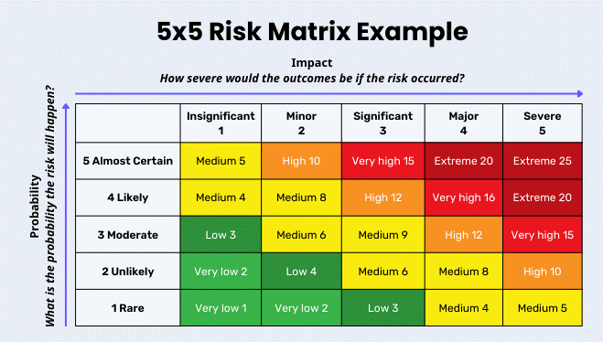 | - 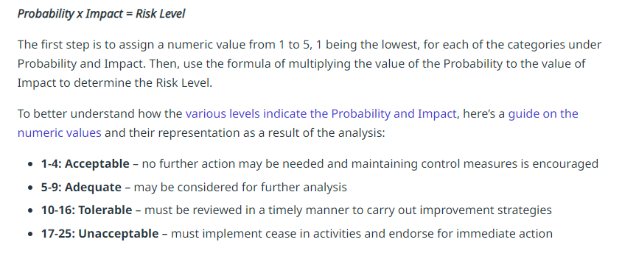
- 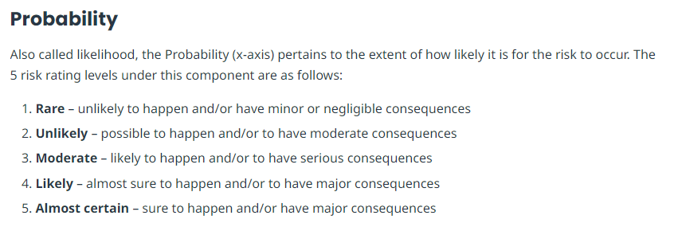 | - 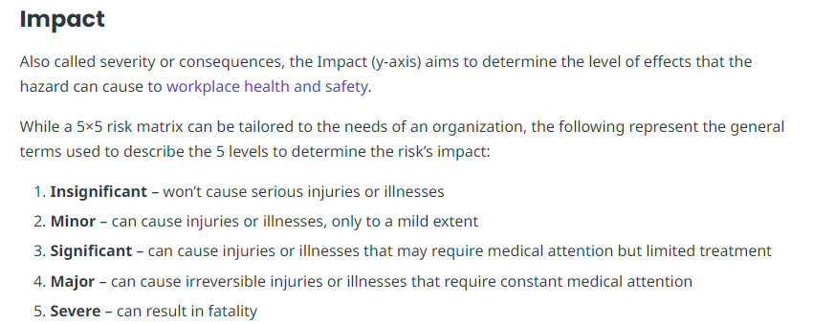
  - Example: the likelihood (probability) of an identified risk happening is ‘Likely’= 4 and the impact on the community would be seen as ‘Significant’ = 3
Therefore, 3 x 4 = 12 – The risk is ‘Tolerable’ (High) and a risk mitigation strategy is required to be identified.
  - https://safetyculture.com/topics/risk-assessment/5x5-risk-matrix/

