  - Round Two 2024-25
Project Proposal Form
Please complete all sections in this form and return to the NT Emergency Service by 5pm ACST, XXXXXXX 2024 via email at: ntdrf@pfes.nt.gov.au.

The following forms must be completed for the project to be considered:
 | 1) Project Proposal (this document) |  | 2) Project Logic
 | 3) Project Budget |  | 4) Risk Assessment

Project Title

Contact Information
Organisation name
(incl ABN if applicable)
Contact Person
Position
Email
Phone

Checklist
Project readiness | - Has the project secured relevant internal approvals, including an approved business case, if required?
 | - Will the project be ready to commence from July 2023 and has a viable 3-year schedule?
 | - Does the Project have assigned resources with the relevant experience and project management capability to deliver the project?
Project funding | - Is the Project a large scale project of greater than $1 million including co-contributions?
 | - Has the Project secured, or have a viable plan to secure, co-contribution funding?

Project Information
What is the Problem?

The Solutions and Goals
Will this project directly support people from  (or who identify as)  belonging to, specific population sub-groups? | - Aboriginal and Torres Strait Islander Peoples  - Children (aged 0 -15 years)  - Individuals experiencing domestic and family violence  - People from a culturally and linguistically diverse background  - People from the LGBTQI+ community  - People with a disability  - People with mental illness  - Seniors  - Youth (15-24)  - Other – please specify
Project Location/s
Describe areas that will be impacted by the project within the Northern Territory
Project Location Type  (select only one option) | - LGA  - Multi-LGA  - State/Territory Wide  - Multi-State/Territory
Project Period
(1, 2 or 3 years)
Project Start Date
Hazard type(s) being targeted | Refer to the DRF Guidelines: Section 4 for Eligible disaster types
Project Activity Type(s) | Infrastructure  - Investment in grey infrastructure  - Investment in green-blue infrastructure (including nature based solutions)  - Investment in hazard monitoring infrastructure  - Business case development for future infrastructure  Systemic risk reduction  - Supporting a better understanding of risk, through a better evidence base to understand and raise awareness of risk  - Strengthening decision making by enhancing governance networks and communities of practice  - Adaptation projects that improve land use planning and development practice projects  - Projects that build the capacity and capability of businesses, community sector organisation and/or at-risk communities  - Projects that enable and incentivise private investment in disaster risk reduction

FUNDING SOUGHT
DRF (Commonwealth) funding amount requested: | $
Co-contribution: | $
Co-contribution type: | - Financial (already approved)  - In-kind  - In principle (pending approval)  - Mixed – please complete: | Mixed – where co-contribution is split:  Financial $  In-kind $  In principle $
TOTAL project cost =  Cwlth + co-contribution | $

Funding information
Has financial assistance previously been or currently being sought through Commonwealth, State/Territory or other initiatives to support this project? | - Yes  - No  If yes, provide further details of the Program the project was submitted to and the outcome of the application process.
Co-contribution waivers/reductions being sought | Is a co-contribution waiver or reduction being sought for this project?  - Yes  - No  If yes,  - Waiver in full  - Reduction
Co-contribution waiver/reduction details  Leave blank if not required. | Provide a rationale as to why a waiver or reduction is being sought.  Note: waivers or reductions are only expected to be provided in exceptional circumstances. It is up to the applicant to make a strong case. Decisions will be made by the Federal Minister for Emergency Management.  Enter the total value and percentage against the Cwlth contribution that you are seeking to have waived or reduced.  If a reduction, enter the total value and percentage against the Cwlth contribution you expect to provide.  If a reduction, advise whether the co-contribution is already confirmed or anticipated.  A Business Case providing funding options must be lodged with NEMA to request a waiver of co-contributions. A business case template is available from NTDRF@pfes.nt.gov.au  The business case for a funding waiver must be lodged directly with NEMA at disaster.ready@nema.gov.au . Where the request is not approved by NEMA, the application cannot be submitted for funding in this round.

DRF Selection Criteria
CRITERIA ONE – Project Details 40%
Provide a detailed description of your project including the project scope, activities and expected outcomes.
Your response must include statements on:
- What the project is, in detail?
- What risk or problem does the Project seek to address?
- An indication of the risks before and after the proposed project?
(complete the attached risk assessment)
- Who (or what) does this project impact and how?
- What evidence (quantitative/qualitative) can you draw on to indicate the size and severity of the risk?
- How will the Project enable adaptation to future climate and disaster impacts?
- How the project will avoid and manage the potential for maladaptation (including any potentially negative social, environmental or economic outcomes)?
Project Details (Please limit to 1 page)
Please provide a detailed description of the Project’s scope, activities and expected outcomes.
What risk does the project address and how?

Project supporting evidence
Please explain how and provide information on the supporting plans, studies, frameworks and strategies or any other supporting evidence e.g. news articles, local reports that support your project?
Evidence provided should identify the disaster severity and risks being addressed by this project.
(Must provide at least 2 types of supporting evidence)

Identify how the project enables adaptation to future climate and disaster impacts?

Is there potential for any maladaptation as an outcome from this project?
Is there potential for any negative social, environmental or economic outcomes that could occur as a result of this project?

Criteria TWO – Likelihood of Project Success 30%
- Your response must address the following:
- Confirmation of the ability to deliver this project within the agreed 3 year timeframes
- Evidence of capacity to complete the project to meet industry standards
- Evidence of capacity and capability (including previous experience in undertaking similar scale projects)

Criteria THREE – Alignment with existing plans and strategies 30%
Your response must include:
- Detail on how the Project aligns with any existing state, territory or local government disaster risk reduction policies, such as:
- National Disaster Risk Reduction Framework
- Second National Action Plan
- Territory Emergency Management Council Strategic Plan 2020-23
- Territory Emergency Plans
- Other plans, policies and legislation; and

- Detail regarding why this Project is not able to be funded through other potentially more appropriate sources

Project aligns with DRF OBJECTIVES
Projects must identify how they align with at least one or all of the DRF’s objectives
Disaster Ready Fund Objectives
One: Increases the understanding of natural hazard disaster impacts, as a first step towards reducing disaster impacts in the future.
Two: Increases the resilience, adaptive capacity and/or preparedness of governments, community service organisations and affected communities to minimise the potential impact of natural hazards and avert disasters
Three: Reduces the exposure to risk, harm and/or severity of a natural hazards impacts, including reducing the recovery burden for government and vulnerable and/or affected communities.

Other relevant considerations and information the applicant may wish to provide

Attachments
Required Attachments must be completed:
- Project logic form
- Indicative Project budget
- Project Risk Assessment
Waiver requested – DRF business case (optional):
- A Business Case with options for funding has been lodged with NEMA- copy of approved business case attached
Optional Additional Attachments
Additional attachments can be provided as listed below to support claims in the application (optional).
Maximum size limit per file is 20MB.
- Optional 1: Title________________________________
- Optional 2: Title________________________________
- Optional 3: Title________________________________
- Optional 4: Title________________________________
- Optional 5: Title________________________________
  - End of form

Declaration
Authorisation should be by a person who has authority to sign on behalf of the organisation.

I/We certify that the information given in this application is true and correct.

I/We agree the information disclosed in this submission may be disclosed to other government agencies, reviewers and staff assisting with the administration or promotion of the NT Application.

I/We declare to the best of my/our knowledge, there are no perceived or existing conflicts of interest to declare.

I/We certify I/we have read the Australian Government guidelines and understand the monitoring and evaluation obligations for successful Projects.
Signature
Printed Name
Position
Date

  - Round Two 2024-25 Project Logic Form
Project: <insert title>
Problem Statement: <indicate the underlying issue that you are trying to address>. Maximum 400 characters including spaces
Solution/Goal: <explain how you intend to address the issue outlined in your problem statement>. Maximum 400 characters including spaces
P
Your planned work |  | Your intended results
Inputs | Outputs: | Short to medium-term outcomes  (timeframe) | Long-term outcomes  (timeframe)
<Indicate the resources you will have>  <Consider:  - People and staffing  - Funding  - Time  - Knowledge  - Networks  - Places and spaces  - Equipment  - Partner organisations and groups> | <Describe the activities that are part of your project. For example, what will have been done when you have finished delivering the project?*>  *Be careful not to confuse outputs (what is delivered) with outcomes (what changes are caused). | <Describe what will be different once your activities are completed? Short term outcomes would usually be expected on completion of a project, and often include changes in skills, knowledge, attitude, awareness or motivation. Medium-term outcomes may take some time to be seen, and can include changes in behaviour, practice or systems or the application of skills and knowledge.> | <Describe any long term outcomes as a result of your project being completed. This should link to your goal statement and resolve the issue in your problem statement.>
Assumptions: <indicate what unexamined beliefs you may have about how or why the project will work. This could be assumptions around the participants, engagement, activities etc>. |  | External factors: <indicate what is outside of your control but could impact your project, e.g. political, social, cultural and geographic environments that influence project delivery and outcomes.>

  - Round Two 2024-25 Indicative Project Budget
Project: <insert title>
Total amount sought from the Commonwealth: <insert AUD in $000s>

# | Milestone | Timeframe | Total budget  ($000s) | Commonwealth contribution  ($000s) | Co-contribution ($000s)
 | <specify deliverable title>  <provide high level summary of what the deliverable entails> | Financial Year – as specific as possible | $ | $ | $
 |  | TOTAL | $ | $ | $

All figures should be GST exclusive. Refer to Section 5 of the DRF Guidelines for eligible and ineligible expenditure types. Eligible expenditure may include:
% for contingencies | Writing, reporting and consultation costs directly related to the delivery of the project | Planning costs; staffing and salaries | Upgrading materials and assets related to project within intent of project
Administration costs, training and utilities for project | Community engagement and project delivery | Direct project costs

Example only (delete this page prior to submitting proposal)
# | Milestone | Timeframe | Total budget  ($000s) | Commonwealth contribution  ($000s) | Co-contribution ($000s)
1 | Development of an implementation plan  Develop a project management plan including details on implementation timeframe milestones, a comprehensive itemised budget, risk and risk management/mitigation strategies and project monitoring | 2024-25 | $10,000 | $5,000 | $5,000
2 | Literature review and modelling –  Develop a state-wide literature review into the proposed approach | 2024-25 | $100,000 | $50,000 | $50,000
3 | Pre-construction –  Design and documentation, site investigation, land costs | 2024-25 | $100,000 | $50,000 | $50,000
4 | Contractor Costs –  Management, Earthworks, Drainage and Supplies | 2024-25 | $100,000 | $50,000 | $50,000
5 | Project Management –  Administration and project management and monitoring costs | 2024-25 –  2026-27 | $100,000 | $50,000 | $50,000
6 | Report –  Administration and project management and monitoring costs | 2026-27 | $100,000 | $50,000 | $50,000
 |  | TOTAL | $510,000 | $255,000 | $255,000

  - Round Two 2024-25 Project Risk Assessment
Project: <insert title>

# | Project Risk Description | Risk Type | Likelihood  (Probability) | Impact | Risk Rating  score | Mitigation Action
 | Short description of the risk identified.  i.e. poor project management; staff illness; scope creep; exceeding budget; loss of suppliers. “Risk of consultant failing to complete contract”; “Failure to identify xxxx” | Financial/ Supply/ Labour/ Political/ Safety /community risk | Almost certain/ Likely/ Possible / Unlikely/ Rare | Severe / Major / /Significant/ Minor/ insignificant | Likelihood x Impact = | High (17-25) – for urgent action – Mitigation Strategy required  Medium (10-16) – for attention/further analysis – strategies in place  Low (1-9) – No action required
1
2
3
4
5

Project Manager: Date: / /2024 Signature:
  - How to calculate risk (delete this page prior to submitting proposal)
- 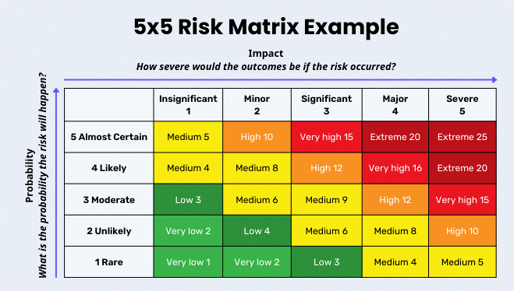 | - 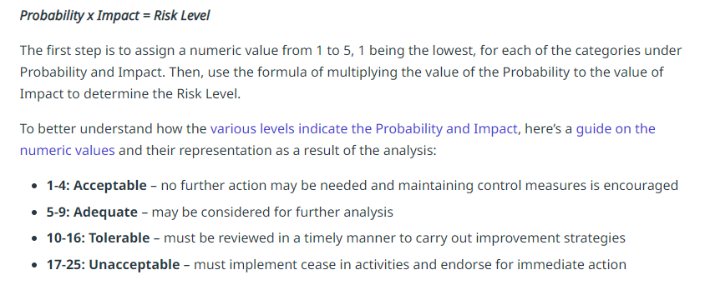
- 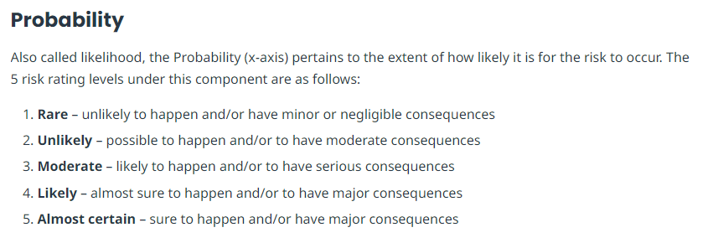 | - 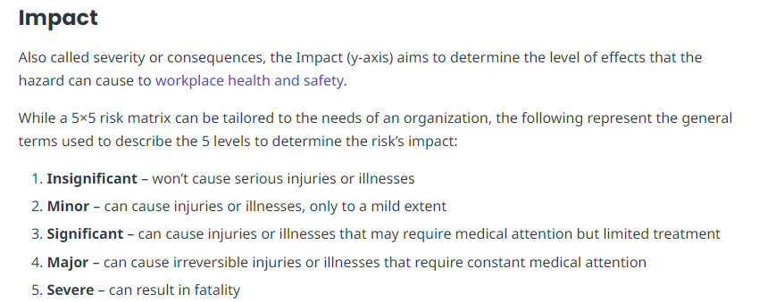
  - Example: the likelihood (probability) of an identified risk happening is ‘Likely’= 4 and the impact on the community would be seen as ‘Significant’ = 3
Therefore, 3 x 4 = 12 – The risk is ‘Tolerable’ (High) and a risk mitigation strategy is required to be identified.
  - https://safetyculture.com/topics/risk-assessment/5x5-risk-matrix/

